**UNIVERSITI MALAYSIA TERENGGANU**

**Faculty Of Computer Sciences and Mathematics**

**Web Based Application Development**

**CSM3023**

Lab Report 5

**Prepared for:**

Sir Mohd Arizal Shamsil bin Mat Rifin

**Prepared by:**

Muhammad Imran Bin Abd Hamid (S66803)

Bachelor of Computer Science (Mobile Computing) with Honors.

Sem 2 2023/2024

Task 1: Using Scriplet to Access a Simple JavaBeans

Code:

|  |
| --- |
| <%--  Document : Messsage1  Created on : 8 May 2024, 2:32:45 pm  Author : MUHAMMAD IMRAN BIN ABD HAMID  --%>  <%@page contentType="text/html" pageEncoding="UTF-8"%>  <%@page language = "java"%>  <%@page info="Using JSP Standard Action to call JavaBeans"%>  <%@page import="java.util.Date, lab5.com.Message"%>  <!DOCTYPE html>  <html>  <head>  <meta http-equiv="Content-Type" content="text/html; charset=UTF-8">  <title>Using JSP Page</title>  </head>  <body>  <h1>Using JSP Scriplet to call JavaBeans</h1>  <%  Message objMsg = new Message();    objMsg.setMsg("Welcome to CSF3023 Course...!");    out.println("<p>"+ objMsg.getMsg()+"</p>");    out.println("<p>Current date is "+ new java.util.Date()+"</p>");  %>  </body>  </html> |

|  |
| --- |
| package lab5.com;  /**  *  * @author MUHAMMAD IMRAN BIN ABD HAMID  */  public class Message {  private String msg;  public Message() {  }    public Message(String msg) {  this.msg = msg;  }  public String getMsg() {  return msg;  }  public void setMsg(String msg) {  this.msg = msg;  }    } |

Output:

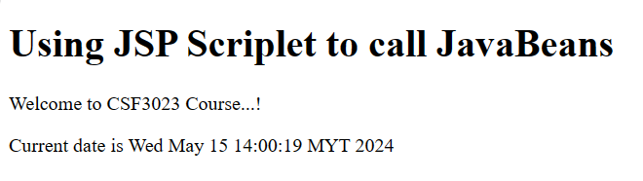

Reflection:

1. Learned how to use JavaBeans in JSP and how to call them using JSP scriplets

2. JSTL provides a set of tags that encapsulate core functionality common to many JSP applications. This method help to keeping Java code out of JSP file by making it easier to read and maintenance.

JSP scriplets allow to directly embed Java code within JSP page using tag.

Task 2: Problem Solving using JavaBeans

Code:

|  |
| --- |
| <%--  Document : registerTraining  Created on : 8 May 2024, 3:01:36  Author : MUHAMMAD IMRAN BIN ABD HAMID  --%>  <%@page contentType="text/html" pageEncoding="UTF-8"%>  <!DOCTYPE html>  <html>  <head>  <meta http-equiv="Content-Type" content="text/html; charset=UTF-8">  <title>Zass Coder Camp</title>  </head>  <body>  <h1>Register IT Training</h1>  <fieldset>  <legend>Training Registration</legend>  <form action="processTraining.jsp">  <table>  <tr>  <td>  <label for="icNo">IC No</label>  </td>  <td>  <input type="text" id="icNo" name="icNo" placeholder="E.g.:911210-05-1234">  </td>  </tr>  <tr>  <td>  <label for="name">Name</label>  </td>  <td>  <input type="text" id="name" name="name" placeholder="Enter your name">  </td>  </tr>  <tr>  <td>  <label for="trainingType">Type of Training</label>  </td>  <td>  <select name="trainingType" id="trainingType">  <option value="1">C++ training</option>  <option value="2">Java for beginner</option>  <option value="3">HTML5</option>  <option value="4">Java EEE</option>  <option value="5">Android Programming</option>  </select>  </td>  </tr>  <tr>  <td>  <label for="noOfPax">No of Pax</label>  </td>  <td>  <input type="text" id="noOfPax" name="noOfPax" placeholder="No of pax">  </td>  </tr>  <tr>  <td>  <input type="radio" id="yes" name="isStudent" value="1">  <label for="yes">Yes</label>  <input type="radio" id="no" name="isStudent" value="0">  <label for="no">No</label>  </td>  </tr>  <tr>  <td>  <button type="submit" value="Submit">Submit</button>  <button type="reset" value="Reset">Cancel</button>  </td>  </tr>  </table>  </form>  </fieldset>  </body>  </html> |

|  |
| --- |
| package lab5.com;  /**  *  * @author MUHAMMAD IMRAN BIN ABD HAMID  */  public class Register {  private String icNo;  private String name;  private int trainingType;  private int noOfPax;  private int isStudent;  public Register() {  }  public Register(String icNo, String name, int trainingType, int noOfPax, int isStudent) {  this.icNo = icNo;  this.name = name;  this.trainingType = trainingType;  this.noOfPax = noOfPax;  this.isStudent = isStudent;  }  public String getIcNo() {  return icNo;  }  public void setIcNo(String icNo) {  this.icNo = icNo;  }  public String getName() {  return name;  }  public void setName(String name) {  this.name = name;  }  public int getTrainingType() {  return trainingType;  }  public void setTrainingType(int trainingType) {  this.trainingType = trainingType;  }  public int getNoOfPax() {  return noOfPax;  }  public void setNoOfPax(int noOfPax) {  this.noOfPax = noOfPax;  }  public int getIsStudent() {  return isStudent;  }  public void setIsStudent(int isStudent) {  this.isStudent = isStudent;  }    public String getTrainingName(int trainingType){  String name = "";  switch(trainingType){  case 1:  name = "C++ training";  break;  case 2:  name = "Java for beginner";  break;  case 3:  name = "HTML5";  break;  case 4:  name = "Java EEE";  break;  case 5:  name = "Android Programming";  break;  }  return name;  }    public double getTrainingFee(int trainingType, int noOfPax, int isStudent){  double fee = 0;    if(isStudent == 1){  switch(trainingType){  case 1:  fee = 3000 * noOfPax * 0.9;  break;  case 2:  fee = 3000 * noOfPax * 0.9;  break;  case 3:  fee = 2800 * noOfPax * 0.9;  break;  case 4:  fee = 5500 * noOfPax * 0.9;  break;  case 5:  fee = 3200 * noOfPax * 0.9;  }  }else{  switch(trainingType){  case 1:  fee = 3000 * noOfPax;  break;  case 2:  fee = 3000 * noOfPax;  break;  case 3:  fee = 2800 * noOfPax;  break;  case 4:  fee = 5500 * noOfPax;  break;  case 5:  fee = 3200 * noOfPax;  break;  }  }  return fee;  }    public String stud2Str(int isStudent){  String studStr = "";  if(isStudent == 1){  studStr = "Yes";  }else{  studStr = "No";  }  return studStr;  }  } |

|  |
| --- |
| <%--  Document : processTraining  Created on : 8 May 2024, 3:33:48 pm  Author : MUHAMMAD IMRAN BIN ABD HAMID  --%>  <%@page contentType="text/html" pageEncoding="UTF-8"%>  <%@page import="lab5.com.Register"%>  <!DOCTYPE html>  <html>  <head>  <meta http-equiv="Content-Type" content="text/html; charset=UTF-8">  <title>Zass Coder Camp</title>  <style>  p{  color: blue;  font-family: Comic Sans MS;  }  </style>  </head>  <body>  <h1>Training Registration Acknowledgement</h1>  <%  String ic_num = request.getParameter("icNo");  String name = request.getParameter("name");  int type = Integer.parseInt(request.getParameter("trainingType"));  int pax_num = Integer.parseInt(request.getParameter("noOfPax"));  int isStudent = Integer.parseInt(request.getParameter("isStudent"));  %>    <%  Register zRegister = new Register(ic_num, name, type, pax_num, isStudent);  // Assign value..  zRegister.setIcNo(ic_num);  zRegister.setName(name);  zRegister.setTrainingType(type);  zRegister.setNoOfPax(pax_num);  zRegister.setIsStudent(isStudent);    // Display value...  out.println("<p>IC No : " + zRegister.getIcNo() + "</p>");  out.println("<p>Name : " + zRegister.getName() + "</p>");  out.println("<p>Type of Training : " + zRegister.getTrainingName(type) + "</p>");  out.println("<p>Number of Pax : " + zRegister.getNoOfPax() + " person/s</p>");  out.println("<p>Student: " + zRegister.stud2Str(isStudent) + "</p>");  out.println("<p>Amount Due : RM " + String.format("%.2f", zRegister.getTrainingFee(type, pax_num, isStudent)) + "</p>");  %>      </body>  </html> |

Output:

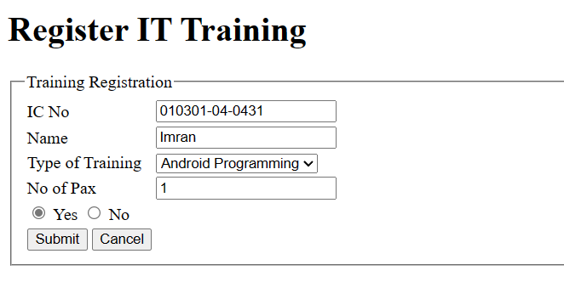

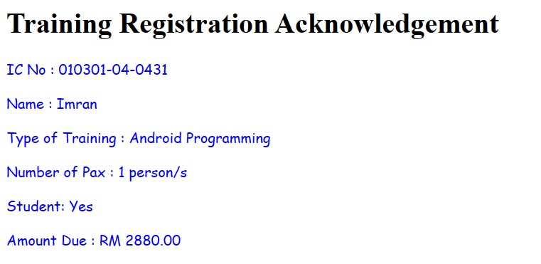

Reflection:

1. learn how to create a JavaBean named Register to handle registration details for IT training.

2.

▪ Determine the properties needed for registration. Declare private variables for each property in the Java class.

▪ Implement a no-argument constructor and another constructor that accepts parameters for initializing the properties.

▪ Generate getter and setter methods for each property.

▪ Implement additional methods as needed for functionality

Task 3: Installing JSTL Taglibs

Output:

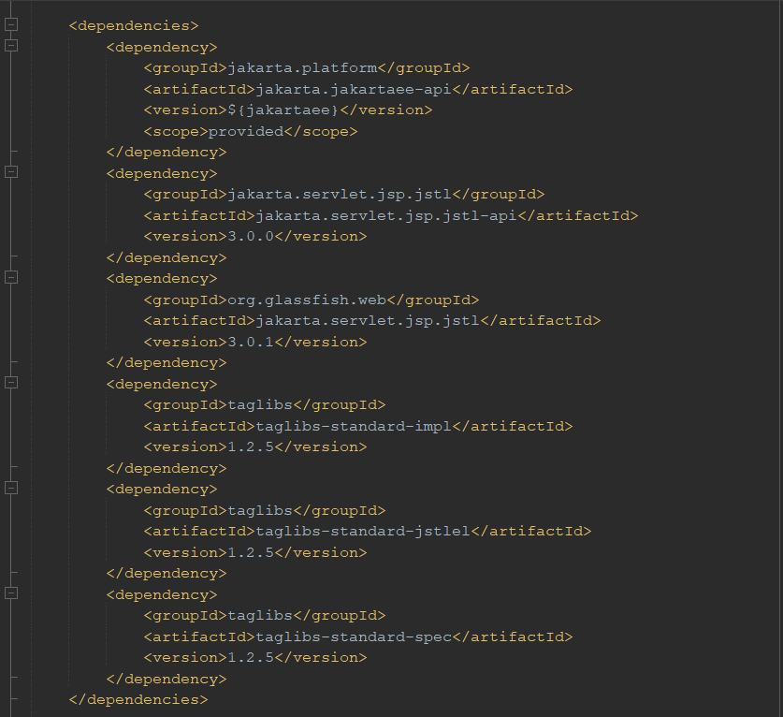

Reflection:

1. Learned how to install JSTL Taglibs in a web application project.

Task 4: Using Java Standard Tag Library (JSTL)

Code 1:

|  |
| --- |
| <%--  Document : jstlCore1  Created on : 11 May 2024, 10:39:53 pm  Author : MUHAMMAD IMRAN BIN ABD HAMID  --%>  <%@ page contentType="text/html" pageEncoding="UTF-8" %>  <%@ taglib prefix="c" uri="jakarta.tags.core" %>  <!DOCTYPE html>  <html>  <head>  <meta http-equiv="Content-Type" content="text/html; charset=UTF-8">  <title>Using JSTL Tag Library</title>  </head>  <body>  <h1>Use JSTL's Features</h1>  <c:set var="message" value="Welcome to CSM3023 - Web Programming courses..!" />  <p><c:out value="${message}" /></p>  </body>  </html> |

Output 1:

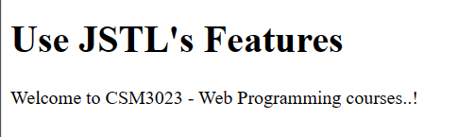

Code 2:

|  |
| --- |
| <!DOCTYPE html>  <html>  <head>  <title>User Registration</title>  <meta charset="UTF-8">  <meta name="viewport" content="width=device-width, initial-scale=1.0">  </head>  <body>  <h1>User Registration</h1>  <form action="processUser.jsp">  <fieldset>  <legend><b>User Details</b></legend>  <table>  <tbody>  <tr>  <td><label for="userName">Name</label></td>  <td><input type="text" name="userName" id="userName" placeholder="Enter your name" required></td>  </tr>  <tr>  <td><label for="userSurname">Surname</label></td>  <td><input type="text" name="userSurname" id="userSurname" placeholder="Enter your surname" required></td>  </tr>  <tr>  <td><label for="userPassword">Password</label></td>  <td><input type="password" name="userPassword" id="userPassword" placeholder="Max 10 characters" maxlength="10" required></td>  </tr>  <tr>  <td>Gender</td>  <td>  <input type="radio" name="userGender" id="male" value="1" required>  <label for="male">Male</label>  <input type="radio" name="userGender" id="female" value="2">  <label for="female">Female</label>  </td>  </tr>  <tr>  <td>Type of User</td>  <td>  <select name="userType" id="userType" required>  <option value="1">Beginner</option>  <option value="2">Intermediate</option>  <option value="3">Advanced</option>  </select>  </td>  </tr>  <tr>  <td>Preferred Language</td>  <td>  <input type="checkbox" name="userLanguage" id="malay" value="1">  <label for="malay">Malay</label>  <input type="checkbox" name="userLanguage" id="english" value="2">  <label for="english">English</label>  <input type="checkbox" name="userLanguage" id="mandarin" value="3">  <label for="mandarin">Mandarin</label>  <input type="checkbox" name="userLanguage" id="tamil" value="4">  <label for="tamil">Tamil</label>  </td>  </tr>  <tr>  <td><br></td>  <td>  <button type="reset" aria-label="Cancel registration">Cancel</button>  <button type="submit" aria-label="Submit registration">Submit</button>  </td>  </tr>  </tbody>  </table>  </fieldset>  </form>  </body>  </html> |

|  |
| --- |
| <%--  Document : processUser  Created on : 11 May 2024, 12:30:42 pm  Author : MUHAMMAD IMRAN BIN ABD HAMID  --%>  <%@ page contentType="text/html" pageEncoding="UTF-8" %>  <%@ taglib prefix="c" uri="jakarta.tags.core" %>  <!DOCTYPE html>  <html>  <head>  <meta http-equiv="Content-Type" content="text/html; charset=UTF-8">  <title>User Registration</title>  </head>  <body>  <h1>Retrieve info using c:param & display it using c:out</h1>  <p>Name: <c:out value="${param.userName}" /></p>  <p>Surname: <c:out value="${param.userSurname}" /></p>  <p>  Gender:  <c:choose>  <c:when test="${param.userGender == 1}">Male</c:when>  <c:when test="${param.userGender == 2}">Female</c:when>  </c:choose>  </p>  <p>  Type of user:  <c:choose>  <c:when test="${param.userType == 1}">Beginner</c:when>  <c:when test="${param.userType == 2}">Intermediate</c:when>  <c:when test="${param.userType == 3}">Advanced</c:when>  </c:choose>  </p>  <p>  Preferred Language(s):  <c:choose>  <c:when test="${paramValues.userLanguage != null}">  <c:forEach items="${paramValues.userLanguage}" var="lang">  <c:choose>  <c:when test="${lang == 1}">Malay</c:when>  <c:when test="${lang == 2}">English</c:when>  <c:when test="${lang == 3}">Mandarin</c:when>  <c:when test="${lang == 4}">Tamil</c:when>  </c:choose>  </c:forEach>  </c:when>  <c:otherwise>None Selected</c:otherwise>  </c:choose>  </p>  </body>  </html> |

Output 2:

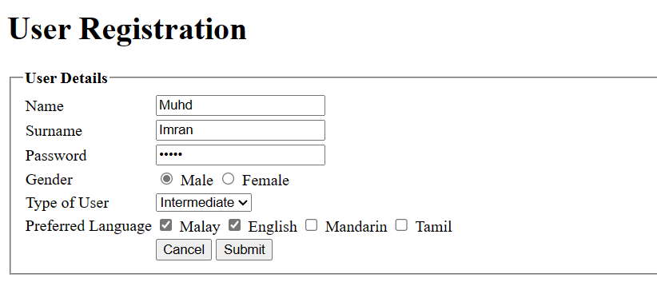

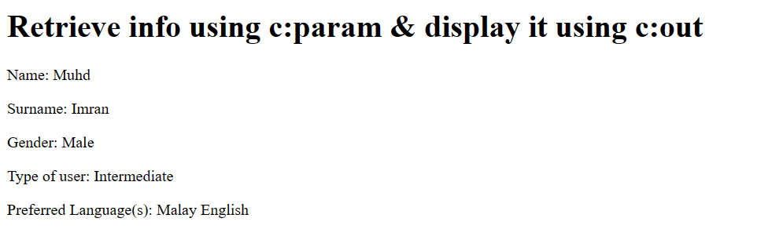

Code 3:

|  |
| --- |
| <%--  Document : jstlFormat1  Created on : 12 May 2024, 10:26:13 pm  Author : MUHAMMAD IMRAN BIN ABD HAMID  --%>  <%@ page contentType="text/html" pageEncoding="UTF-8" %>  <%@ taglib prefix="c" uri="jakarta.tags.core" %>  <%@ taglib prefix="fmt" uri="jakarta.tags.fmt" %>  <!DOCTYPE html>  <html>  <head>  <meta http-equiv="Content-Type" content="text/html; charset=UTF-8">  <title>JSTL Formatting Tag</title>  </head>  <body>  <h1>Using JSTL Formatting Tag for Formatting</h1>  <!-- Assign specific number to variable -->  <c:set var="total" value="2880.4638" />  <p>Number to be formatted is <c:out value="${total}" /></p>    <p>Formatting number as currency with currency code:  <fmt:formatNumber type="currency" currencyCode="MYR" value="${total}" /></p>    <p>Formatting number to the nearest 2 integer digits:  <fmt:formatNumber type="number" maxIntegerDigits="2" value="${total}" /></p>    <p>Formatting number by grouping:  <fmt:formatNumber type="number" groupingUsed="true" value="${total}" /></p>    <p>Formatting number to 3 decimal places:  <fmt:formatNumber type="number" groupingUsed="false" maxFractionDigits="3" value="${total}" /></p>    <p>Formatting number to percentage:  <fmt:formatNumber type="percent" groupingUsed="false" value="${total}" /></p>  </body>  </html> |

Output 3:

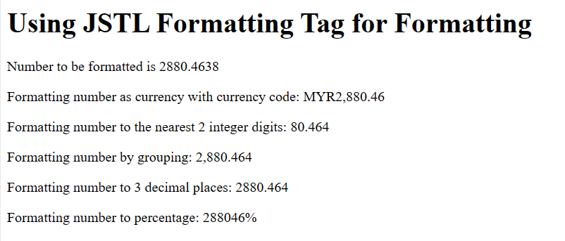

Reflection:

1. Provide a standardized set of tags that facilitate common tasks in JSP development.

2. Core tags, Formatting tags, SQL tags, XML tags, Function.

Task 5: Using JSP Standard Tag Library

Code 1:

|  |
| --- |
| <%--  Document : fmt_formatDate  Created on : 12 May 2024, 11:39:44 pm  Author : MUHAMMAD IMRAN BIN ABD HAMID  --%>  <%@ page contentType="text/html" pageEncoding="UTF-8" %>  <%@ taglib prefix="c" uri="jakarta.tags.core" %>  <%@ taglib prefix="fmt" uri="jakarta.tags.fmt" %>  <!DOCTYPE html>  <html>  <head>  <meta http-equiv="Content-Type" content="text/html; charset=UTF-8">  <title>fmt:formatDate Example</title>  </head>  <body>  <h2>fmt:formatDate Examples</h2>  <!-- a Date time string -->  <c:set var="now" value="<%= new java.util.Date() %>" />    <p>  Time (fmt:formatDate type="time"):  <strong><fmt:formatDate type="time" value="${now}" /></strong>  </p>    <p>  Date (fmt:formatDate type="date"):  <strong><fmt:formatDate type="date" value="${now}" /></strong>  </p>    <p>  Date, Time (fmt:formatDate type="both"):  <strong><fmt:formatDate type="both" value="${now}" /></strong>  </p>    <p>  Date, Time Short (fmt:formatDate type="both" dateStyle="short" timeStyle="short"):  <strong><fmt:formatDate type="both" dateStyle="short" timeStyle="short" value="${now}" /></strong>  </p>    <p>  Date, Time Medium (fmt:formatDate type="both" dateStyle="medium" timeStyle="medium"):  <strong><fmt:formatDate type="both" dateStyle="medium" timeStyle="medium" value="${now}" /></strong>  </p>    <p>  Date, Time Long (fmt:formatDate type="both" dateStyle="long" timeStyle="long"):  <strong><fmt:formatDate type="both" dateStyle="long" timeStyle="long" value="${now}" /></strong>  </p>    <p>  Date, Time (dd-MM-yyyy HH:mm:ss):  <strong><fmt:formatDate pattern="dd-MM-yyyy HH:mm:ss" value="${now}" /></strong>  </p>    <!-- Store in variable -->  <fmt:formatDate pattern="dd-MM-yyyy HH:mm" value="${now}" var="nowString" />  <p>  Now String (dd-MM-yyyy HH:mm):  <strong><c:out value="${nowString}" /></strong>  </p>  </body>  </html> |

Output 1:

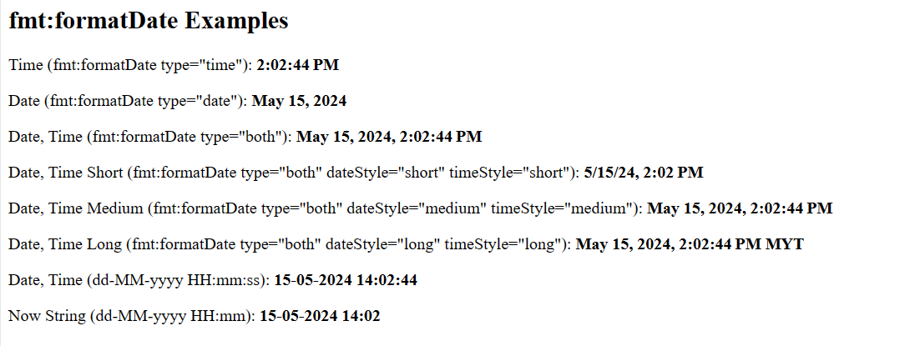

Code 2:

|  |
| --- |
| <%--  Document : fmt_parseDate  Created on : 12 May 2024, 12:43:44 pm  Author : MUHAMMAD IMRAN BIN ABD HAMID  --%>  <%@ page contentType="text/html" pageEncoding="UTF-8" %>  <%@ taglib prefix="c" uri="jakarta.tags.core" %>  <%@ taglib prefix="fmt" uri="jakarta.tags.fmt" %>  <!DOCTYPE html>  <html>  <head>  <meta http-equiv="Content-Type" content="text/html; charset=UTF-8">  <title>fmt:parseDate Examples</title>  </head>  <body>  <h2>fmt:parseDate Examples</h2>  <c:set var="dateTimeString" value="17-11-2015 11:49" />  <h4>  dateTimeString:  <c:out value="${dateTimeString}" />  </h4>  <!-- Parsing a date time string, and storing in a variable of type java.util.Date -->  <fmt:parseDate value="${dateTimeString}" type="both" var="parsedDateTime" pattern="dd-MM-yyyy HH:mm" />  <p>  The date after parsing:  <c:out value="${parsedDateTime}" />  </p><br>  <p>  Date only (dd/MM/yyyy):  <fmt:formatDate value="${parsedDateTime}" pattern="dd/MM/yyyy" />  </p>  </body>  </html> |

Output 2:

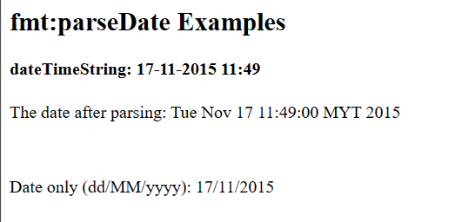

Reflection:

1. Learned how to format dates, parse dates, and combine formatting with core tags.

Exercise 1:

Code:

|  |
| --- |
| <%--  Document : circle  Created on : 13 May 2024, 10:14:08 pm  Author : MUHAMMAD IMRAN BIN ABD HAMID  --%>  <%@ page contentType="text/html" pageEncoding="UTF-8" %>  <%@ taglib prefix="c" uri="jakarta.tags.core" %>  <%@ taglib prefix="fmt" uri="jakarta.tags.fmt" %>  <!DOCTYPE html>  <html>  <head>  <meta http-equiv="Content-Type" content="text/html; charset=UTF-8">  <title>Find area of a circle</title>  </head>  <body>  <h1>Find area of a circle</h1>  <form>  <table>  <tr>  <td><label for="radius">Radius</label></td>  <td><input type="number" name="radius" id="radius" required></td>  <td><button type="submit">Calculate</button></td>  </tr>  </table>  </form>  <c:if test="${param.radius != null}">  <c:set var="radius" value="${param.radius}" />  <c:set var="area" value="${Math.PI * radius * radius}" />  <c:set var="perimeter" value="${2 * Math.PI * radius}" />  <p>Radius: <c:out value="${radius}" /></p>  <p>Area:  <fmt:formatNumber type="number" groupingUsed="false" maxFractionDigits="3" value="${area}" />  </p>  <p>Perimeter:  <fmt:formatNumber type="number" groupingUsed="false" maxFractionDigits="3" value="${perimeter}" />  </p>  </c:if>  </body>  </html> |

Output:

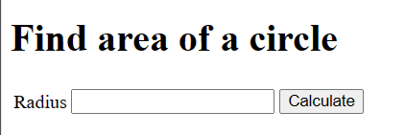

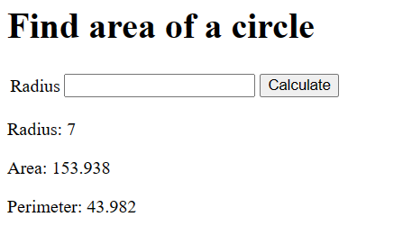

Exercise 2:

Code:

|  |
| --- |
| package lab5.com;  /**  *  * @author MUHAMMAD IMRAN BIN ABD HAMID  */  public class Stock {  private int numShares;  private double pricePerShare;  private double commissionRate;  public Stock() {  }  public Stock(int numShares, double pricePerShare, double commissionRate) {  this.numShares = numShares;  this.pricePerShare = pricePerShare;  this.commissionRate = commissionRate;  }  public int getNumShares() {  return numShares;  }  public void setNumShares(int numShares) {  this.numShares = numShares;  }  public double getPricePerShare() {  return pricePerShare;  }  public void setPricePerShare(double pricePerShare) {  this.pricePerShare = pricePerShare;  }  public double getCommissionRate() {  return commissionRate;  }  public void setCommissionRate(double commissionRate) {  this.commissionRate = commissionRate;  }  public double getCommissionRateAsPercentage() {  return (commissionRate <= 1) ? commissionRate * 100 : commissionRate;  }  public double calculateStockCost() {  return numShares * pricePerShare;  }  public double calculateCommission() {  return calculateStockCost() * commissionRate;  }  public double calculateTotalCost() {  return calculateStockCost() + calculateCommission();  }  @Override  public String toString() {  return String.format(  "StockPurchase [numShares=%d, pricePerShare=%.2f, commissionRate=%.2f%%, stockCost=%.2f, commission=%.2f, totalCost=%.2f]",  numShares, pricePerShare, getCommissionRateAsPercentage(), calculateStockCost(), calculateCommission(), calculateTotalCost()  );  }  public static void main(String[] args) {  Stock purchase = new Stock(100, 50.0, 0.05);  System.out.println(purchase);  }  } |

|  |
| --- |
| <%--  Document : stock  Created on : 13 May 2024, 11:14:29 pm  Author : MUHAMMAD IMRAN BIN ABD HAMID  --%>  <!DOCTYPE html>  <html>  <head>  <title>Stock Purchase</title>  <meta charset="UTF-8">  <meta name="viewport" content="width=device-width, initial-scale=1.0">  </head>  <body>  <h1>Stock Purchase</h1>  <form action="stock_process.jsp">  <table>  <tr>  <td><label for="shareNum">Number of Shares:</label></td>  <td><input type="number" name="shareNum" id="shareNum" min="0" required></td>  </tr>  <tr>  <td><label for="sharePrice">Price per Share:</label></td>  <td><input type="number" name="sharePrice" id="sharePrice" min="0" step="0.01" required></td>  </tr>  <tr>  <td><label for="comRate">Commission Rate (%):</label></td>  <td><input type="number" name="comRate" id="comRate" min="0" max="100" required></td>  </tr>  <tr>  <td><br><button type="submit">Calculate</button></td>  </tr>  </table>  </form>  </body>  </html> |

|  |
| --- |
| <%--  Document : stock_process  Created on : 13 May 2024, 12:02:16 pm  Author : MUHAMMAD IMRAN BIN ABD HAMID  --%>  <%@ page contentType="text/html" pageEncoding="UTF-8" %>  <%@ taglib prefix="c" uri="jakarta.tags.core" %>  <%@ taglib prefix="fmt" uri="jakarta.tags.fmt" %>  <!DOCTYPE html>  <html>  <head>  <meta http-equiv="Content-Type" content="text/html; charset=UTF-8">  <title>Stock Purchase Results</title>  </head>  <body>  <c:set var="shareNum" value="${param.shareNum}" />  <c:set var="sharePrice" value="${param.sharePrice}" />  <c:set var="comRate" value="${param.comRate}" />  <jsp:useBean id="purchase" class="lab5.com.Stock">  <jsp:setProperty name="purchase" property="numShares" value="${shareNum}" />  <jsp:setProperty name="purchase" property="pricePerShare" value="${sharePrice}" />  <jsp:setProperty name="purchase" property="commissionRate" value="${comRate / 100}" />  </jsp:useBean>  <h2>Stock Purchase Details</h2>  <p>Number of Shares: <c:out value="${purchase.getNumShares()}" /></p>  <p>Price per Share: <fmt:formatNumber type="currency" currencySymbol="RM" groupingUsed="false" maxFractionDigits="2" value="${purchase.getPricePerShare()}" /></p>  <p>Commission Rate: <fmt:formatNumber type="number" groupingUsed="false" maxFractionDigits="0" value="${purchase.getCommissionRateAsPercentage()}" />%</p>  <br>  <h2>Stock Purchase Results</h2>  <p>Stock Cost: <fmt:formatNumber type="currency" currencySymbol="RM" groupingUsed="false" maxFractionDigits="2" value="${purchase.calculateStockCost()}" /></p>  <p>Commission: <fmt:formatNumber type="currency" currencySymbol="RM" groupingUsed="false" maxFractionDigits="2" value="${purchase.calculateCommission()}" /></p>  <p>Total Cost: <fmt:formatNumber type="currency" currencySymbol="RM" groupingUsed="false" maxFractionDigits="2" value="${purchase.calculateTotalCost()}" /></p>  </body>  </html> |

Output:

